

NAME : HAJRA ZAHID
REG NO. : BSE203075
SUBJECT : OOP LAB
ASSIGNMENT NO. : 11
DESCRIPTION : PRACTICE TASK
SUBMITED TO : SIR TEMOUR ABBAS

Walkthrough:
Code:
#include<iostream>
#include<string>
using namespace std;

class instructor
{
private:
string name;

public:
instructor(string x) : name(x)
{ }

string get_name()
{
return name;
}
~instructor () //first this destructor called
{
cout<<"\ninstructor destructor called"<<endl;
}
};

class department //department has oenership
{
private:
instructor * obj;

public:
department(instructor * ins) : obj(ins)
{ }

~department() //secondly this destructor called
{
cout<<"destructor called"<<endl;
}
};

int main()
{
instructor * instruct;
string inname;
instruct= new instructor("ali ahmed");
inname = instruct->get_name();
cout<<"the name of insytructor is "<<inname<<endl;

department dept(instruct);
delete instruct; //both classes ave their own life cycle
}

Output:
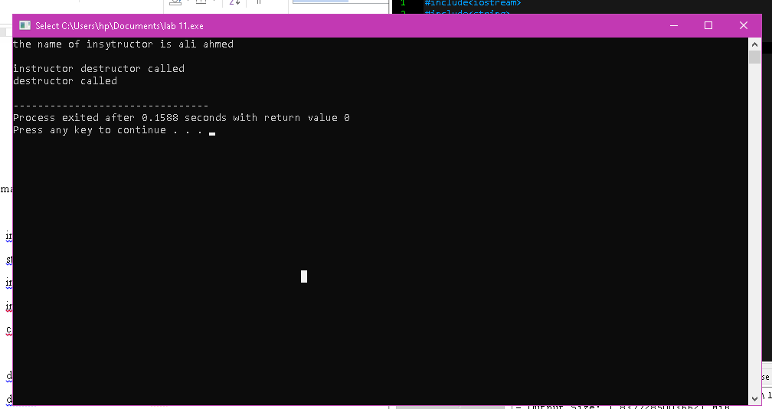

Practice task 01:
UML-Diagram:
Department
Department name
Location
Sector

Sector
Sector id
Sect name
Sector()
Display()

Person
Name
Age
Person()
Display()

Laboratory
Lab id
Access level
Sect id
Experiment no.
Lab()
Set access()
Display()

Scientist
Sci name
Dept
Designation
Scientist()

Engineer
Lab
Engineer()

Code:
#include<iostream>
#include<string>
using namespace std;

//composition between lab and sector class
//agregation between department, lab ,scientistm engineer
//inheritance person, scientist, engineer

class Sector;
class Department
{
private:
string department_name, location;
Sector * sect;
};

class Sector
{
public:
int sect_id;
string sect_name;

public:
Sector(int x, string y)
{
sect_id = x;
sect_name = y;
}
void display()
{
cout<<"\n--------------sctor details --------------"<<endl;
cout<<"sector id : "<<sect_id<<endl;
cout<<"sector name : "<<sect_name<<endl;
}

~Sector()
{
cout<<"\nsector destructor "<<endl;
}
};

class Person
{
private:
string name;
int age;

public:
Person(string a, int b)
{
name = a;
age = b;
}

void display()
{
cout<<"\n-------------- person details ------------------"<<endl;
cout<<"name : "<<name<<endl;
cout<<"age : "<<age<<endl;
}
};

class Scientist : public Person
{
public:
string sci_name, designation;
Department * dept;

public:
Scientist(string x, string y, string z, int g) : Person(z, g)
{
sci_name = x;
designation = y;
}
};

class Laboratory
{
public:
int lab_id, access_level, sect_id, experiment_no;
Sector *s1;
Scientist *obj;

public:
Laboratory(int x, int y, Sector *s2, Scientist *obj2)
{

s1 = new Sector(0 , "\0"); //composition relation as te object is given new memory space
sect_id = s1->sect_id;
lab_id = x;
experiment_no = y;

set_access(obj2);
}

void set_access(Scientist *obj1) //passing scintist object for accessing designation which sets access level
{
this->obj = obj1;
string check;
check = obj->designation;

if (check == "senior")
{
access_level = 1;
}
else if( check == "junior")
{
access_level = 2;
}
else if(check == "helper")
{
access_level = 3;
}
}

void display() //displaying informatin of lab and scientist
{
cout<<"\n----------------------lab details -----------------------"<<endl;
cout<<"lab id : "<<lab_id<<endl;
cout<<"scientist name : "<<obj->sci_name<<endl;
cout<<"designation : "<<obj->designation<<endl;
cout<<"experiment number : "<<experiment_no<<endl;
cout<<"access level : "<<access_level<<endl;
}

~Laboratory()
{
delete s1;
cout<<"\nlaboratory destructor"<<endl;
}
};

class Engineer : public Person
{
Laboratory *l1;

public: //setoing values of lab by using engineer class constructor
Engineer (int a, int b, Laboratory* lab1, string f, int g) : Person(f, g)
{

this->l1 = lab1;
l1->lab_id = a;
l1->experiment_no = b;
}
};

int main() //in main asking user about entering values according to question
{
Department d;

int x; string y;
cout<<"enter sector id : ";
cin>>x;
cout<<"enter sector name : ";
cin.ignore();
getline (cin, y);
Sector *s;
s = new Sector(x, y);//pointer object of sector

string f; int g;
cout<<"enter person name : ";
getline(cin, f);
cout<<"enter person age : ";
cin>>g;

string a, b;
cout<<"entr scientist name : ";
cin.ignore();
getline(cin, a);
cout<<"enter designation (senior, junior, helper ): ";
getline (cin, b);
Scientist sci(a, b, f ,g );

Laboratory *l;
l = new Laboratory(0, 0, s, &sci); //creating lab object and pointer

int m, n;
cout<<"enter lab id : ";
cin>>m;
cout<<"enter experiment number : ";
cin>>n;
Engineer e(m, n, l, f, g);

s->display();
sci.display();
l->display();

delete l;
}

Output:
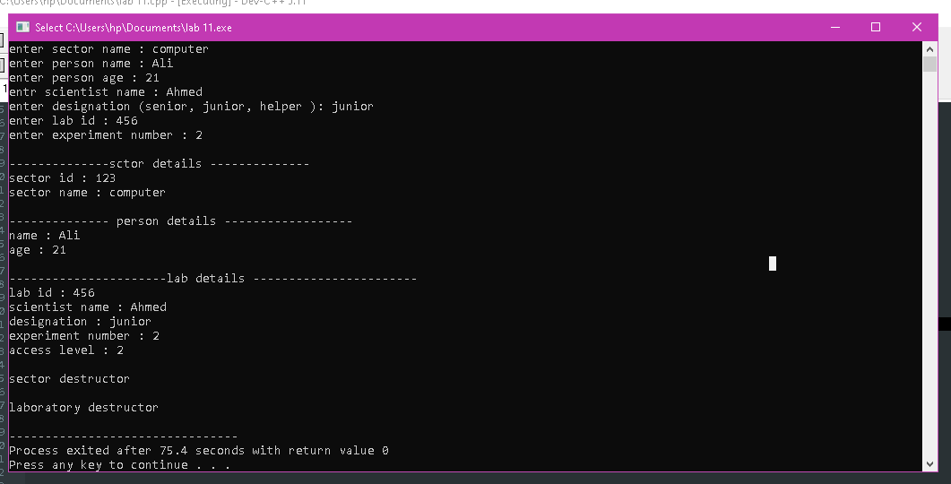

Practice task 02:
Code:
#include<iostream>
#include<conio.h>
#include<string>
using namespace std;

class employee
{
public:
string name1, designation;
int age1;

void set_data_employe()
{
cout<<"enter your name : ";
cin.ignore();
getline(cin , name1);
cout<<"enter designation : ";
cin>>designation;
cout<<"enter age : ";
cin>>age1;
}
};

class student
{
public:
string name, department;
int age;

void set_student_data()
{
cout<<"enter name : ";
cin.ignore();
getline(cin, name);
cout<<"enter department : ";
getline(cin, department);
cout<<"enter age : ";
cin>>age;
}
};

class customer //agregtion relation
{
employee *emp;
student *stu;
public:
void getting_employe_data(employee *emp1)
{
this->emp = emp1;
emp->set_data_employe();
}

void getting_student_data(student *stu1)
{
this->stu = stu1;
stu->set_student_data();
}
};

class food //agregation relation
{
customer * c1;
public:

int x;
int counting, count;
char ch1;
void show_menu(customer * d1)
{
counting = 0;
count = 0;
this->c1 = d1;
do
{
cout<<"\nwhich food item do yo like\n press 1 for fast food \npress 2 for proper meal \n press 3 for baverage"<<endl;
cin>>x;

switch(x)
{
case 1:
{
int z = 0, burger = 60, sandwitch = 50, cold_drink = 30, fries = 50;
cout<<"\nenter which type of fast sood yo like : "<<endl;
cout<<"press 1 for burger \n 2 for sandwitch \n 3 for cold drink \n 4 for fries : ";
cin >> z;
switch(z)
{
case 1:
{
counting += burger;
count++;
break;
}
case 2:
{
counting += sandwitch;
count++;
break;
}
case 3:
{
counting += cold_drink;
count++;
break;
}
case 4:
{
counting += fries;
count++;
break;
}
}
break;
}
case 2:
{
int z = 0, paratha = 40, chapati = 20, chiken = 180, rice = 200, beef = 250;
cout<<"\nenter which type of proper food you like : "<<endl;
cout<<"press 1 for paratha \n 2 for chapati \n 3 for chiken \n 4 for rice \n 5 for beef : ";
cin >> z;
switch(z)
{
case 1:
{
counting += paratha;
count++;
break;
}
case 2:
{
counting += chapati;
count++;
break;
}
case 3:
{
counting += chiken;
count++;
break;
}
case 4:
{
counting += rice;
count++;
break;
}
case 5:
{
counting += beef;
count++;
}
}
break;
}

case 3:
{
int z = 0, tea = 40, cofee = 60, juice = 80, soda = 20;
cout<<"\nenter which type of baverage food you like : "<<endl;
cout<<"press 1 for tea \n 2 for cofee \n 3 for juice \n 4 for soda : ";
cin >> z;
switch(z)
{
case 1:
{
counting += tea;
count++;
break;
}
case 2:
{
counting += cofee;
count++;
break;
}
case 3:
{
counting += juice;
count++;
break;
}
case 4:
{
counting += soda;
count++;
break;
}
}
break;
}
}
cout<<"\ndo you want tp bye any other item (y/n) : ";
cin>>ch1;
}while(ch1 == 'y' || ch1 == 'Y');
}

~food()
{
cout<<"\ndeletig food"<<endl;
}

};

class bill //composition relation
{
food *f1;
employee *e;
student *ss1;
int a, b;
public:
void show_bill(food *foo, employee *e1)
{
this->e = e1;
this->f1 = foo;
f1 = new food;
a = foo->count;
b = foo->counting;
cout<<"\n-------DETIALS OF PERSON-------------"<<endl;
cout<<"name of customer : "<<e->name1<<endl;
cout<<"your designation : "<<e->designation<<endl;
cout<<"your age is : "<<e->age1<<endl;
cout<<"the total items you bye are : "<<a<<endl;
cout<<"your total bill is : "<<b<<endl;
}

void show_bill(food *foo, student *ss)
{
this->ss1 = ss;
this->f1 = foo;
f1 = new food;
a = foo->count;
b = foo->counting;
cout<<"\n-------DETIALS OF PERSON-------------"<<endl;
cout<<"name of customer : "<<ss1->name<<endl;
cout<<"your department : "<<ss1->department<<endl;
cout<<"your age is : "<<ss1->age<<endl;
cout<<"the total items you bye are : "<<a<<endl;
cout<<"your total bill is : "<<b<<endl;
}

~bill()
{
delete f1;
cout<<"\ndeleting bill"<<endl;

cout<<"---------Thank you-----------"<<endl;
}
};

int main()
{
customer *cost;
cost = new customer;
employee *emp;
emp = new employee;
student *s1;
s1 = new student;
int abc = 0;
int def = 0;
int x;

do
{
cout<<"ARE YOU EMPLOYE OR STUDENT OF INSTITUTE \nPRESS 1 FOR EMPLOYE \nPRESS 2 FOR STUDENT"<<endl;
cin>>x;
switch(x)
{
case 1:
{
abc++;
cost->getting_employe_data(emp);
break;
}
case 2:
{
def++;
cost->getting_student_data(s1);
break;
}
default:
{
cout<<"\nyou enterd a wrong choice:"<<endl;
cout<<"re-enter chice"<<endl;
break;
}
}

}while(x<=0 || x>2);

food *menu;
menu = new food;
menu->show_menu(cost);

bill *b;
if(abc>0)
{
b = new bill;
b->show_bill(menu, emp);
}
else if(def > 0)
{;
b = new bill;
b->show_bill(menu, s1);
}
delete b;
}

Output:
